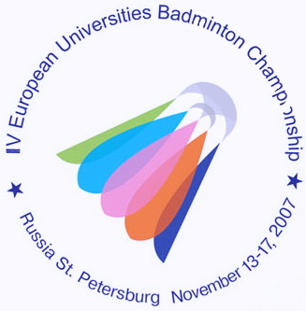
IV ЧЕМПИОНАТ ЕВРОПЫ ПО БАДМИНТОНУ
СРЕДИ СТУДЕНТОВ

13-17 ноября 2007 года Санкт-Петербург
4th EUROPEAN UNIVERSITIES BADMINTON CHAMPIONSHIP
St.PETERSBURG NOVEMBER 13-17, 2007

Press-release № 9
16.11.2007

In the 4th EUBC matches in doubles are held today in the morning. After 2 rounds which were played yesterday we can say that there is no sensation. The best pairs in MD, WD and MX continue to compete today. One of the quarterfinals was between two Russian teams: the first pair on this tournament Andrey Ashmarin/Anton Nazarenko (Moscow State University of Forestry) faced to Vladimir Ivanov/Nikita Khakimov (University of Chelyabinsk). In the third game when the score was 20:20 the umpire gave one point to Ivanov/Khakimov but sportsmen from Moscow were sure that there was out. Ashmarin got yellow card with umpire, which change his decision. To sum up students from Moscow, leaders in MD, lost the match to the sportsmen from Chelyabinsk 1:2 (21-16, 15-21, 20-22).
Three Russian double teams will take part in the semifinals in MD. Vladimir Ivanov/Nikita Khakimov will be playing with Sergey Lunev/Alexei Vasil’ev (University of Vladivostok, Russia) and Viktor Malutin/Nikolay Ukk (Finec, Russia) will face to Peter Zauner/Roman Zirnwald (Austria). The Austrian team is the second draw on this tournament. They remain the main pretenders to the gold medals in MD after defeat of Ashmarin/Nazarenko.
In WD two leading teams Liz Brett/Caroline Smith (The UK) and Karoline Neumann/Klaudia Klingerhoffer (Germany) with no problems defeated their opponents in quarterfinals and continue to struggle for the medals. English sportsmen will play with the Russian team Lubov Chudentseva/Anastacia Naumenkova (University of Chelyabinsk) who played in quarterfinal with Julia Hauber/Verena Roth and won hardly. Karoline Neumann/Claudia Klingelhoffer will face to another Russian pair Valeria Rojdestvenskaya/Ksenia Polikarpova (Finec, St.Petersburg) in semifinal. The sportsmen from Finec defeated Tanya Spennhoff/Laura Ufermann (Germany) in quarterfinal 2:1 (20-22, 21-18, 21-14).
In MX the most exciting quarterfinal was between the Russian pair Anton Nazarenko/Elena Shimko (University of Moscow) and the German team Alexander Roovers/Laura Ufermann. Russians lost the first game however did well at the end of the second game and finally won the whole match 2:1 (18-21, 21-15, 21-14). Maurice Niesner/Astrid Hoffmann (Germany), Tom Armstrong/Liz Brett (The UK) and Alexey Vasil’ev/Evgenia Dimova also continue to play in the tournament.

Press-centre of the 4th EUBC.

