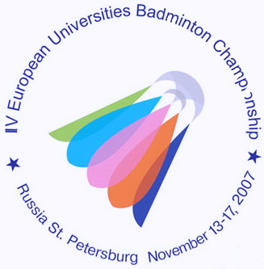
IV ЧЕМПИОНАТ ЕВРОПЫ ПО БАДМИНТОНУ
СРЕДИ СТУДЕНТОВ

13-17 ноября 2007 года Санкт-Петербург
4th EUROPEAN UNIVERSITIES BADMINTON CHAMPIONSHIP
St.PETERSBURG NOVEMBER 13-17, 2007

Press-release № 7
15.11.2007
The individual events in the 4th EUSC starts today. Matches in MS were from 10:00 till 13:00, 56 students from 11 European countries took part. There were 17 Russian sportsmen. Two of them Sergey Ivlev (University of Moscow, Russia) and Vladimir Ivanov (University of Chelyabinsk) began to play in the second round. Other 15 sportsmen had already played one match. Nikita Hakimov faced to Sergey Chulanov and defeated him 2:0 (21-18, 21-17). All other Russian players have won their matches and now successfully continue to compete.
Among the most exciting is worth mentioning the match between Piotr Kowenicki (Poland) and Rui Almeida (Portugal). There was an intensive struggle and finally Piotr won. The score was 2:1 (21-17, 14-21, 21-19).
After midday women started their matches. 35 sportsmen from 8 countries take part in WS. Olena Prus (NTU KHPI, Ukraine) and Elena Shimko (The University of Moscow, Russia) take the 78th and 149th place in the World Ranking accordingly. They started their matches in the 2nd round.
It can be also mentioned that the leading players of the University of Hamburg won the team events yesterday and celebrated their victory greatly with all 4 German teams.
Press-centre of the 4th EUBC.

