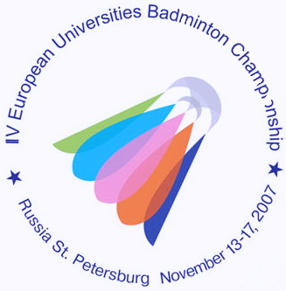
IV ЧЕМПИОНАТ ЕВРОПЫ ПО БАДМИНТОНУ
СРЕДИ СТУДЕНТОВ

13-17 ноября 2007 года Санкт-Петербург
4th EUROPEAN UNIVERSITIES BADMINTON CHAMPIONSHIP
St.PETERSBURG NOVEMBER 13-17, 2007

Press-release № 6
14.11.2007
Jury of Appeal together with Kruse Bastian the technical delegate of EUSA have adjudged the defeat to the University of Vladivostok. The 4th European badminton championship winner in team event is the University of Hamburg (Germany). University of Vladivostok is the second.
Kruse Bastian explained that according to the rules of BWF if one of the sportsmen from two same sex is ill the person who plays instead of him can take part in only one category. So, as Evgenia Dimova has already played in MXD category she couldn’t play in WS with Astrid Hoffman. That is why the results of the match Astrid Hoffman was announced invalid. And one point was given to German team.
The final score is 3:2 and the winner is the University of Hamburg. It’s possible that this decision will be reconsidered. Russian team is going to take an appeal.

Press-centre of the 4th EUBC.

