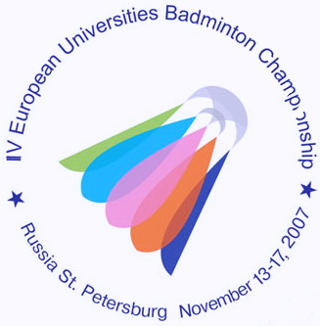
IV ЧЕМПИОНАТ ЕВРОПЫ ПО БАДМИНТОНУ
СРЕДИ СТУДЕНТОВ

13-17 ноября 2007 года Санкт-Петербург
4th EUROPEAN UNIVERSITIES BADMINTON CHAMPIONSHIP
St.PETERSBURG NOVEMBER 13-17, 2007

Press-release № 5
14.11.2007

The team event of the 4th European badminton championship has finished. Final matches were played by University of Vladivostok (Russia) and University of Hamburg (Germany). The match was a hard fighting. Vladivostok defeated Germany 3:2.
In the match for the bronze medals team of Loughborough University (England) lost to NTU KHPI (Ukraine) 3:0. Finec of St. Petersburg (Russia) team took the 7th place. After the final matches several players gave us brief interviews.
Evgeny Dremin (University of Vladivostok, Russia):”We are satisfied with the final match and the results. Our team became the champion of the III EUBS last year. And now we’ve done it again. In addition skills level of our opponents has increased in the last few years. A lot of sportsmen from the World Ranking have already played here, in St. Petersburg. That’s why it can hardly be said that this victory was easy”
Sebastian Jens Schottler (University of Hamburg, Germany):”Undoubtedly we’re disappointed about the results, but there were some problems connected with record. There was one more WD team which appeared in the last moment. In our opinion it doesn’t respect the rules. Among the advantages I can add that the level of sportsmen has increased this year. But we’re not satisfied with our game because we haven’t done our best.”
Olena Prus (NTU KHPI, Ukraine):”We’ve played quite well. We’re happy to become medalists and we’re also pleased to be in St. Petersburg. I’ve never been here but I’ve heard a lot about this city. Unfortunately, until this moment I’ve seen only hotel and Zimniy Stadium. But I’m going to not only to compete but also to have some free time in St. Petersburg. The Championship is organized on the highest level, better than that last year in Lisbon”
German delegation indicates a fall to the technical delegate of EUSA Kruse Bastian. So, the final results haven’t been approved yet.

Press-centre of the 4th EUBC.

