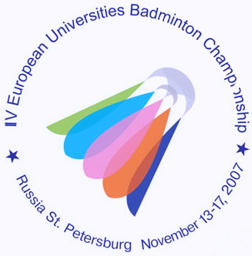
IV ЧЕМПИОНАТ ЕВРОПЫ ПО БАДМИНТОНУ
СРЕДИ СТУДЕНТОВ

13-17 ноября 2007 года Санкт-Петербург
4th EUROPEAN UNIVERSITIES BADMINTON CHAMPIONSHIP
St.PETERSBURG NOVEMBER 13-17, 2007

Press release № 3
13.11.2007

The highest qualification sportsmen from various Europe universities participate In the 4th European universities badminton championship. In the tournament in St. Petersburg take part:
Sergey Ivlev – winner of Russia championship 2006 , the silver medallist 2007 (MS), (Moscow state university of forestry);
Evgeniy Dremin/Evgenia Dimova – the European universities badminton champions, 2006, (MX), ( Far Eastern tehnical university of Vladivostok);
Alexey Vasilyev/ Evgeniy Dremin - the silver medallist of the championship of Russia(MD), 2007, ( Far Eastern tehnical university of Vladivostok);
Vladimir Ivanov – the member of the Russian national team, the winner of the Russian Cup, 2007, the silver medallist of the championship of Russia (MS), the bronze medallist of the European juniors championship (U-21), 2006, (Ural University ).

Olena Prus (Ukraine) - 78th place in the World Ranking, (NTU KHPI, Kharjkov);
Claudia Klingelhofer (Germany) - the bronze medallist of the last European universities badminton championship(WS), (TU Munchen);
Sebastian Jens Schottler (Germany) – the champion of Germany among students(MS), 2007, (University of Hamburg);
Vasos Vasou (Cyprus) – the champion of Cyprus, 2007, the medallist of the European junior championships,(U-21), (University of Cyprus);
Peter Zauner/Roman Zirnwald (Austria) – 100th place in the World Ranking (MD), the champions of Austria among students(MD);

Press-centre
of the 4th European universities badminton championship

