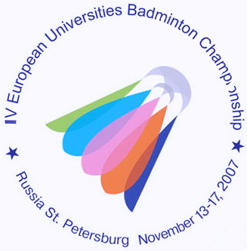
IV ЧЕМПИОНАТ ЕВРОПЫ ПО БАДМИНТОНУ
СРЕДИ СТУДЕНТОВ

13-17 ноября 2007 года Санкт-Петербург
4th EUROPEAN UNIVERSITIES BADMINTON CHAMPIONSHIP
St.PETERSBURG NOVEMBER 13-17, 2007

Press-release № 12
16.11.2007

Today final games in doubles and singles were played in the 4th European University Badminton Championship.
Mixed doubles were played first. Both pairs were from Russia. Anton Nazarenko/Elena Shimko (University of Moscow) lost to Alexey Vasil’ev/Evgenia Dimova (University of Vladivostok, Russia) 2:0 (21-13, 21-12).
Olena Prus (NTU KHPI, Ukraine) is the champion in WS She defeated Mariya Martynenko from the same university. The score was 2:0 (21-16, 21-17).
“The final was very difficult”, – said Olena, tired but very happy. “In Ukraine Mariya is my main opponent. My friends support helped me very much. This is my first international success. The championship was organized on the highest level - a lot of courts, large stadium, and comfortable schedule. If I have an opportunity I will play in St.Petersburg again with pleasure”.
In MS final Jens Roch (Saarland University, Germany) faced Vladimir Ivanov (University of Chelyabinsk). As Jens is left-handed it was very difficult to Vladimir to play him. So the Russian sportsman lost to the German one 2:0 (21-13, 21-19).
“It was very hard to win”, - said Jens. “Frankly speaking the game was equal, but fortunately I captured the initiative. Generally speaking I just was lucky. Also I’d like to point out Nikolay Ukk my opponent in the 3rd round. The Russian sportsman took lots of my energy. That’s why it was not easy for me to prepare for the final match.”
In WD Liz Brett/Caroline Smith (GBR) played against Valeria Rojdestvenskaya/Ksenia Polikarpova (FINEC, St.Petersburg). The pair from the northern capital of Russia won 2:0 (21-19, 21-16) to the great happiness of fans.
The first game was very hard but in the second one we played easier and much more confident. We would like to thank our fans, our relatives and friends. We’re totally happy.
The last match of the championship was hold between two Russian double team
Sergey Lunev/Alexey Vasil’ev (University of Vladivostok, Russia) and Viktor Malutin/Nikolay Ukk (Finec, Russia). There was an intensive struggle and the students from St. Petersburg won. The score was 2:1.
Sergey Shakhray the President of the Nation Russia Badminton Federation commented the results of the 4th EUBC: “This tournament is organized in the year of the 50th badminton anniversary in Russia. Today we’re talking about the revival of the badminton in our country and our sportsmen results confirm this fact. This is the first students championship of such a high level organized in St.Petersburg. Soon the Russian Open will be hold in Moscow where we can see many high ranking players from over the world.
I would like to thank Valentina Matvienko the governor of St. Petersburg. We have a plan about the special sport centre for badminton. This will help to popularize this sport in St. Petersburg. I hope players from the Northern capital to participate in the Olympic Games - 2008 in Beijing. We consider that our sportsmen may achieve Olympic medals.”

Press-centre of the 4th EUBC.

