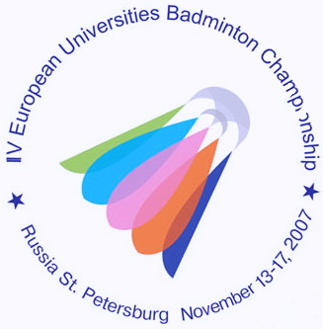
IV ЧЕМПИОНАТ ЕВРОПЫ ПО БАДМИНТОНУ
СРЕДИ СТУДЕНТОВ

13-17 ноября 2007 года Санкт-Петербург
4th EUROPEAN UNIVERSITIES BADMINTON CHAMPIONSHIP
St.PETERSBURG NOVEMBER 13-17, 2007

Press-release № 11
16.11.2007

Today the finalists of the 4th EUBC in singles and doubles were defined. In men’s semifinals Jens Roch (Saarland University) and Russian player Vladimir Ivanov (Ural University) confidently defeated their opponents. Jens played with Sebastian Schottler( Hamburg University) 2:0 (22-20,21-12) and Vladimir competed with Sergey Lunev (University of Vladivostok). The score was 2:0(21-15, 21-18). Schottler and Lunev became the bronzes medalists of the championship.
In women semifinal Maria Martynenko(NTU KHPI, Ukraine) won the match against Ksenia Polikarpova(FINEC, Russia) 2:0(21-14, 21-15). In the final she will have a match with Olena Prus, who defeated in the semifinal Evgenia Dimova(University of Vladivostok) 2:0(21-18,21-17). Polikarpova and Dimova will get tomorrow bronze medals.
In MD 2 Russian pairs got to the final: Sergey Lunev/Alexey Vasil’ev(University of Vladivostok) and Victor Malutin/Nikolay Ukk(FINEC, St. Petersburg). The last team defeated in the semifinal the 2nd pair of this tournament Peter Zauner/Roman Zirnwald (Austria) 2:1(21-18, 19-21, 21-14)
In WD Liz Brett/Caroline Smith (the UK) and the Russian pair Valeria Rojdestvenskaya/Ksenia Polikarpova (Finec, St. Petersburg) became the finalists. Liz Brett/Caroline Smith had an intensive match with Lubov Chydenseva/Anastacia Naymenkova(University of Chelyabinsk) and won 2:1(19-21,21-14,21-14). Valeria Rojdestvenskaya/Ksenia Polikarpova got to the final without struggle because their opponents Karoline Neumann/Klaudia Klingelhofter (Germany) were not able to play in the semifinals.
In MX there were no surprises. Anton Nazarenko/Elena Shimko( Moscow State University of Forestry,Russia) and Alexey Vasil’ev/Evgenia Dimova(University of Vladivostok, Russia) successfully reached the final.

Press-centre of the 4th EUBC.

