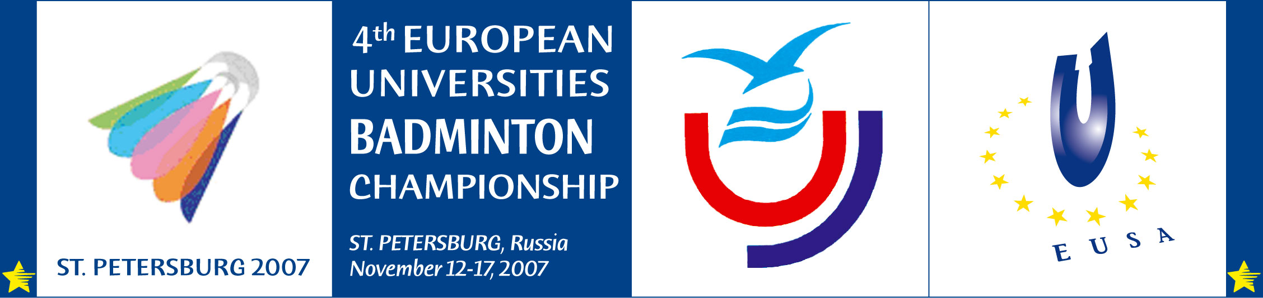

Invitation to the
4th European Universities Badminton Championship
St. Petersburg / Russia 2007

On behalf of the European University Sports Association (EUSA), the Russian Student Sport Union (RSSU) and the Organising Committee we have the pleasure to invite the University Teams from your Country
to participate in the
4th European Universities Badminton Championship (men and women)
which will be organised in
St. Petersburg from November 12-17, 2007.

We may remind you that the deadline for applications has been determined as
August 12, 2007

All relevant information will be published on the EUSA website: www.eusa-unisport.org
and on the official website of the event: website: www.eusa.spb.ru

We would be honoured to welcome teams from your country!

With best sports regards,

Alberto Gualtieri Oleg Matytsin
President of EUSA President of RSSU



